
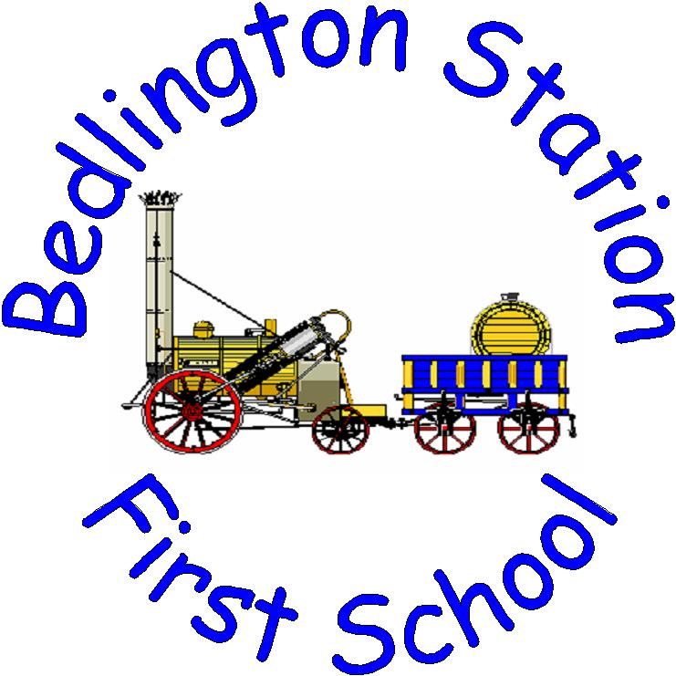


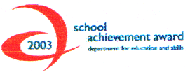





22.03.11
Dear Parents/Carers
As part of our detective work, Maple and Beech classes will be visiting Hancock Museum on the morning of Monday 28th March. We will be back in school for lunch as normal.
On this occasion there will be no charge for this educational visit as the cost is being funded through the Creative Partnership.
We require some parental support for this visit, please indicate on the slip below if you are able to help. We will select names randomly from a hat and you will be notified if you have been selected.
Thank you for your continued support.
Yours sincerely

Mrs P Mulholland
Head Teacher

---------------------------------------------------------------------------------------------------------------------------------

Bedlington Station First School

I give permission for my Child ___________________ Class _________ to attend the educational visit to the Hancock Museum on Monday 28th March.

Signature of Parent/Carer _____________________________

School Road, Bedlington, Northumberland, NE22 7JQ
Telephone: 01670 822326 Fax: 01670 826810
Email: admin@station.northumberland.sch.uk
Web site: www.station.northumberland.sch.uk
Head Teacher: Mrs P Mulholland

